Perform rescue from a live LV panel

This course provides participants with the skills to manage common first aid situations that can arise in an electrical services industry environment, including rescue from low voltage panels. It is suitable for people employed as electricians and others employed in the electrical services industry.
PRE-REQUISITE UNIT
HLTAID009 Provide cardiopulmonary resuscitation is a pre-requisite for this course. For those who do not have the unit of competency will be required to undertake HLTAID009 Provide cardiopulmonary resuscitation prior to commencing UETDRRF004 Perform rescue from a live LV panel
COURSE DURATION
St John offers the following options:
- 1 day face to face workshop: This is full face to face course and participants are required to attend the full session.
- 5 hours (face to face workshop with pre-work): Participants are required to undertake online e-learning module prior to attending the face-to-face workshops for practice and assessment.
- Assessment only: This course is for those who are confident in their skills and only want to complete the assessment.
CERTIFICATE
On successful completion of this course you will be issued a statement of attainment in:
- HLTAID009 Provide cardiopulmonary resuscitation
- UETDRRF004 Perform rescue from a live LV panel
St John recommends, as per the First Aid in the Workplace Code of Practice and the Australian Resuscitation Council guidelines, that first aid skills are renewed every 3 years and resuscitation skills (HLTAID009/HLTAID015) are renewed every 12 months.
COURSE OUTLINE
This course covers the following:
- Introduction to low voltage principles  - Managing the unconscious, breathing casualty  - Cardiopulmonary resuscitation (CPR)  - DRSABCD action plan  - Burns  - Legal issues | - Defibrillation awareness  - Infection control  - Defibrillation awareness  - Hazards and risk management  - Identifying and labelling the isolation point  - Performing a rescue from a low voltage (LV) panel

ASSESSMENT METHODS
A successful outcome for this statement of attainment will be determined by a range of different methods including written assessment, observation of simulated and practical activities etc.
You will be required to demonstrate CPR on a manikin on the floor.
LOCATIONS
St John delivers first aid courses nationally and across many locations in Australia. Choose the location to suit your needs.
- PUBLIC (at a venue near you)
- CUSTOMISED (on-site consultation)
- ONSITE (at a venue of your choice)
- ONLINE (training delivered online from our e-Learning platform)
DELIVERY BY ST JOHN’S RTO PARTNERS
St John Ambulance Australia’s courses are delivered by way of partnership agreements (e.g. with State or Territory St John Ambulance organisations). Our partners are authorised to deliver training on behalf of St John Ambulance Australia Ltd. (TOID 88041). Contact details for our partner organisations are available from www.stjohn.org.au or call 1300 ST JOHN.
PARTICIPANT’S HANDBOOK
Download the Participant’s Handbook from www.stjohn.org.au for more information about completing a course with St John Ambulance Australia. This includes information about complaints, appeals and privacy information.
We actively tailor training to meet the needs of people from diverse backgrounds and abilities and encourage all to apply.
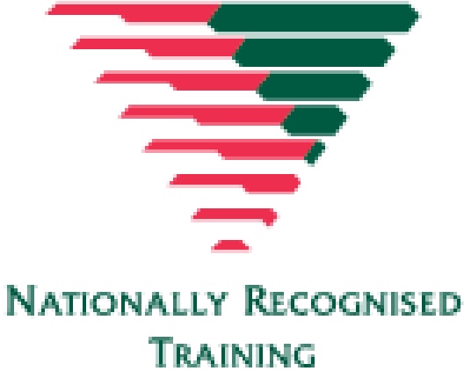
For more information on this course,
contact the Training Office in your area
1300 ST JOHN (1300 785 646) WWW.STJOHN.ORG.AU

